Perform Analytics in Power BI
Explore Statistical Summary
Data is often intertwined with statistics because statistics are one way in which you can explore your data

Statistics show you the distribution of your data and help you identify key takeaways and trends and determine whether outliers exist

Identify Outliers in Power BI
An outlier is a type of anomaly in your data, something you didn’t expect or that surprised you, based on historical averages or results

You will want to identify outliers to isolate data points that significantly differ from other data points

But first you need to constitute what is an outlier

Process of identifying outliers involves segmenting your data into two groups:
- one group – outlier data
- other group – non-outlier data

The best way to identify outlier groups:
- Use a visualization
- DAX formula

These methods will ensure that results are dynamic

Use a Visual to Identify Outliers
The best visual for identifying outliers is a scatter chart

It shows the relationship between two numerical values

Scatter charts display patterns in large sets of data and are, therefore, ideal for displaying outliers

The visual will update and display the data according to the selected fields, and you’ll be able to clearly identify the outliers in the data – they are isolated items that are away from the bulk of the data

An example of a visual depiction of an outlier can be seen below (the outlier is the data that is isolated from the bulk/cluster of data)
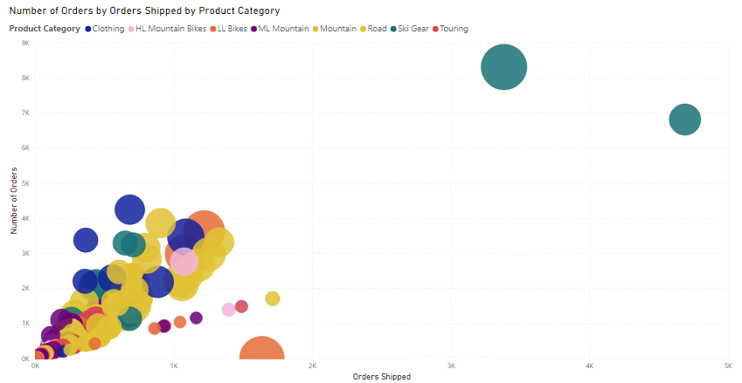

Use DAX to Identify Outliers
You can also use DAX to create a measure that will identify the outliers in your data

An example DAX formula:

Outliers =
CALCULATE (
[Order Qty],
FILTER (
VALUES (‘Product’[Product Name]) ,
COUNTROWS (FILTER (‘Sales’, [Order Qty] >= [Min Qty])) > 0
)
)

In the DAX expression above, Order Qty is a measure in the Sales table and Min Qty refers to the lowest order quantity in the Sales table

Once you have created the outlier measure in DAX.

You can add it into a scatter chart visual as it is the best way of depicting an outlier in your data.

Populate the scatter chart with the fields associated with your DAX and the outlier measure, as seen in the image below:
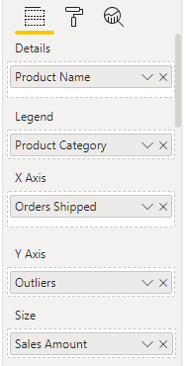

Group and Bin Data for Analysis
When creating visuals,
Power BI aggregates your data into groups, based on the values that it finds in the underlying data

You can refine how those default groups are presented

You can also create new groups:
by grouping two or more data points - grouping
putting values into equal-sized groups - binning

Grouping and Binning ensures that the visuals in the reports display the data according to your preference

Using these features will help you to clearly view, analyse, and explore the data and trends in your visuals

Additionally, you’ll be able to clearly view, analyse, and explore the data and trends in your visuals

This will then provide your users with more specific insights on their data, which can help drive business decisions

Grouping
Grouping is mainly used for categories of data

Create a Group
This section is best depicted by an example, e.g., assume you that you want to group states with sales greater than 500,000 dollars.

You the Ctrl + click the data points that you want to group, Right-click one of those selected data points and then select the Group data option

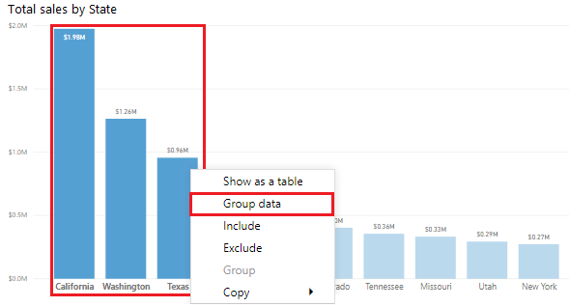
We then get the following visual after grouping the above visual
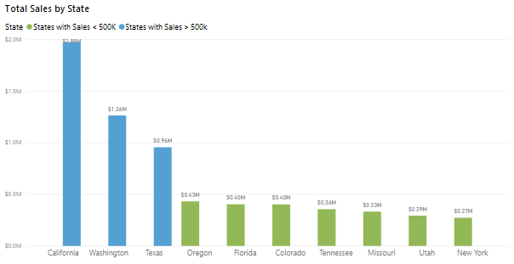
Edit a Group
You can also edit a previously-made group (e..g, the states with sales greater than $500k

This can be done by right-clicking the group field in either the Legend bucket or the Fields pane and then select the Edit Groups

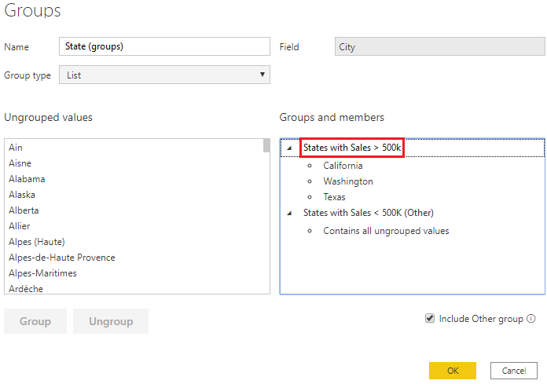

Values in groups need to be manually configured

This means that, any new items/values that appears will be automatically placed in the (Other) ungrouped section of the graph

Hence, you will need to manually place values/items into the created group

Binning
Binning is similar to grouping, but is mainly used for grouping continuous fields, such as numbers and dates

Allows you to group numerical and time field data into “bins” of equal size

Allows you to visualize and identify trends in your data in more meaningful ways
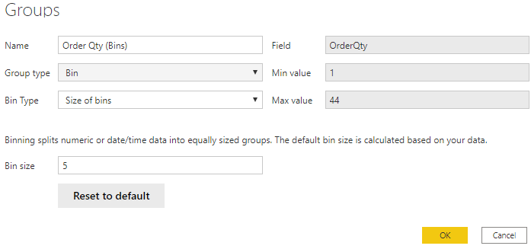
This is again best explained with a visual

In the visual above, we want to create bins (groups) for the Order Qty field.

First start in the Fields pane, by right-clicking the Order Qty field that you want to create the bins for, and then select New Group
On the Groups window that appears, set the Bin size to the size that you want, adjust other settings are required and select OK

The values are then separated/split into the equally sized groups whose total number of bins is USER-DECIDED by the value in the Bin size field

Apply Clustering Techniques
Allows you to identify a segment (cluster) of data that is similar to each other but dissimilar to the rest of the data

Clustering is different to the grouping technique accomplished previously

Clustering allows you to quickly find groups of similar data points in a subset of your data
It analyses your dataset to identify similarities and dissimilarities in the attribute values

and then it separates the data that has similarities into a subset of the data. These subsets are referred to as clusters

Take an initial unclustered dataset
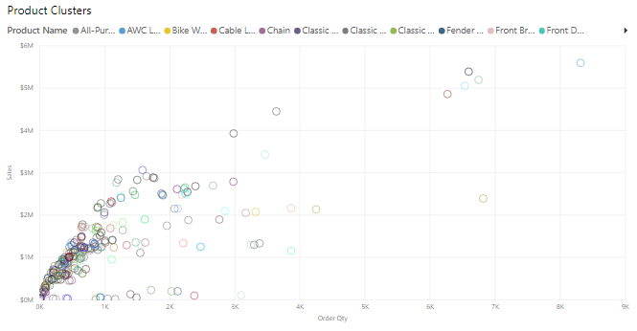
Simply from looking, it is difficult to discern any natural groups – we can then apply clustering to find groups of similar data points

To apply clustering to the scatter chart, select More options (…) in the upper-right corner of the visual and then select Automatically find clusters

In the Cluster window that displays, you can then edit the default name, field, and description as seen in the image below:
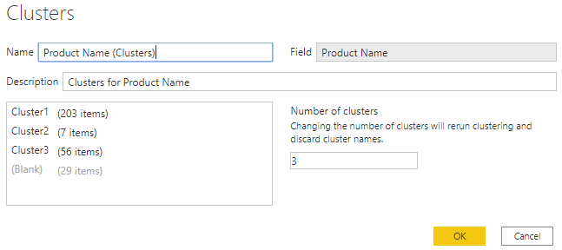
Enter the number of clusters that you want (e.g., 3) into the box and select OK. Power BI will then run the clustering algorithm and create a new categorical field with different cluster groups in it

The image below depicts the previous unclustered dataset with a 3 total clusters

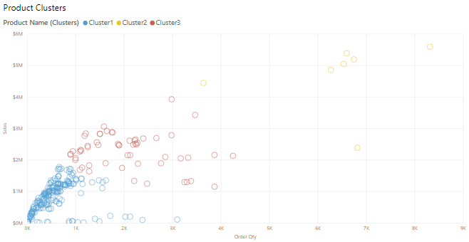
You can now clearly see the clusters that are in the dataset and perform analysis on them

NOTE that:
You can recluster the data with different Number of clusters but this will discard the current clustering and cluster names

We can also use the clusters, which is stored in the scatter chart’s Legend field well bucket, as a source of cross-highlighting like any other Legend field

Use the Analyze Feature
The Analyze feature provides you with additional analysis that is generated by Power BI for a selected data point.

You might want to use this feature if Power BI has found something that you haven’t seen before
or
if you want Power BI to give you a different insight into your data

This feature is useful for analyzing why your data distribution looks the way that it does.

Instead of exploring the data manually, you can use the Analyze feature to get fast, automated, insightful analysis of your data

To use this feature, right-click a data point on the visual and then hover over the Analyze option to display two further options:
Explain the increase
Find where the distribution is different

The options that are available will depend on the data point that you selected

The Analyze feature is demonstrated in the following images:

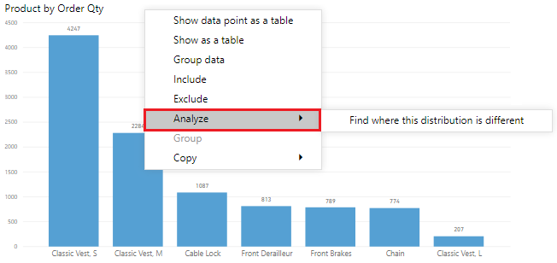
In the example below, you can select the Explain the increase option, and a window displays with a new visual as illustrated in the image below:
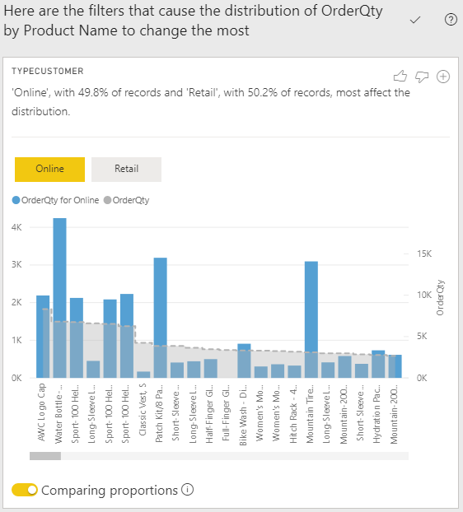

If you found these analysis useful, you can add the new visual to the report so that other users can view it. Select the plus (+) icon in the upper-right corner of the visual to add it to your report
Review Quick Insights
this feature uses machine learning algorithms to go over the entire dataset and produce insights (results) for you quickly

GIANT NOTE
This feature only AVAILABLE in POWER BI SERVICE ONLY
This feature DOES NOT WORK with DirectQuery
This feature ONLY WORKS with data that is IMPORTED into Power BI

This feature is a great way to build dashboards when you don’t know where to start
It can also
help you find insights you might have missed when building your reports

Get Quick Insights on your Dataset
To get quick insights on your dataset, open the Power BI Service and then select the Content tab
Locate the report for which you want to get quick insights then select More options (…) => Quick insights

Once the algorithms has finished running.

Select the View insights to open the Quick Insights page for the selected dataset, and then view the insights that Power BI has found for you

The Quick Insights page contains up to 32 separate insight cards
each card has a chart or graph + a short description

The example below illustrates an insight return by the Quick Insight service
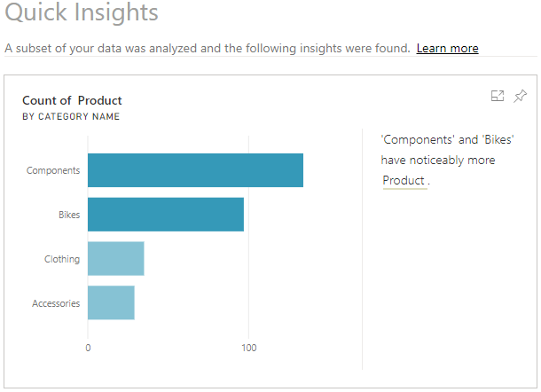
Add a Quick Insights Result Card to a Dashboard
If you see an insight card that is particularly compelling, you can add it to your dashboard

On the Quick Insights page, hover over the card and then select the pin icon. The visual is then added to the dashboard where you can reposition it as required

Interact with the Quick Insight Results
To take a closer look at the particular insight card, you can open it and perform the following actions:
- Filter the visualization by using the available options in the Filters panel
- Pin the insight card to a dashboard by selecting the Pin visual
- Run insights on the card (scoped insights) by selecting Get insights in the upper-right corner
- Return to the original insight canvas by selecting the Exit Focus mode in the upper-left corner

Apply AI Insights
This feature allows you to:
connect to a collection of pre-trained machine learning models that you can apply to your data to enhance your data preparation efforts

To apply AI Insights to the data:
go to Power Query Editor and select the Column tab, three AI insight options will be available for you to choose from:
- Text Analytics
- Vision
- Azure Machine Learning

NOTE:
A Premium capacity/subscription is required to use the Text Analytics and Vision options

Working with AI Visuals in Power BI
Power BI also has advanced AI capabilities that grant you:
the ability to get an answer by asking a question using your own words and answering those questions back to you

Use the Q & A Visual
This feature lets you explore your data in your own words by allowing you to ask natural language questions and then providing you with answers to those questions

The ability to ask questions is VALUABLE to BOTH REPORT AUTHOR and REPORT USER

For the Report Author
It gives you ideas for the type of visuals that you can display in the report
and lets you quickly add those visuals

For the Report User
It gives an effective tool that can be used to get quick answers to their questions about the data
Add the Q & A Visual to your Report Canvas
To access the Q & A feature, you need to add the Q & A visual to the report. It can also be accessed from the Visualizations pane

The Q & A feature is also available as a button, useful for saving space on the report canvas

You can start asking questions immediately by selecting one of the suggested questions or by entering a question into the question box

Setting Up the Q & A Feature
You can set-up the underlying Q & A feature so that it improves in answering questions about your data

Basically, teach the Q & A feature to better understand people

You can also proactively monitor and review the questions that are coming through from users and then address misunderstandings or common typos

Hence, you can constantly calibrate the Q & A feature so that it provides better answers to your organization’s questions

Use the Q & A Feature to Build Visuals
Furthermore, when Power BI answers a question and you find the visual result to be engaging or helpful then you can add it as a standard visual to your report

In order to turn a Q & A result into a standard visual, select the icon next to the question box as shown in the image below:
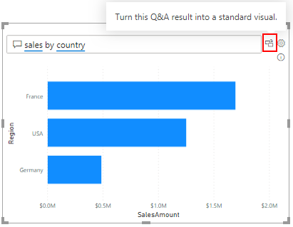

The Q & A feature is unique in that it DOES NOT require users to have knowledge of Power BI to use the visuals

Find Important Factors w/ Key Influencers Visual
The key influencer visual helps you understand the factors that are affecting a specific metric.

The visual analyses your data for you, ranks the factors that matter and then displays those factors as key influencers

The visual also helps you to contrast the relative importance of these factors,

meaning that you can build your visuals while understanding what factors impact those visuals and why the visuals appear the way they do

We can then add a Key influencers visual to the report by selecting the Key influencers icon on the Visualization pane

The visual can be configured by:
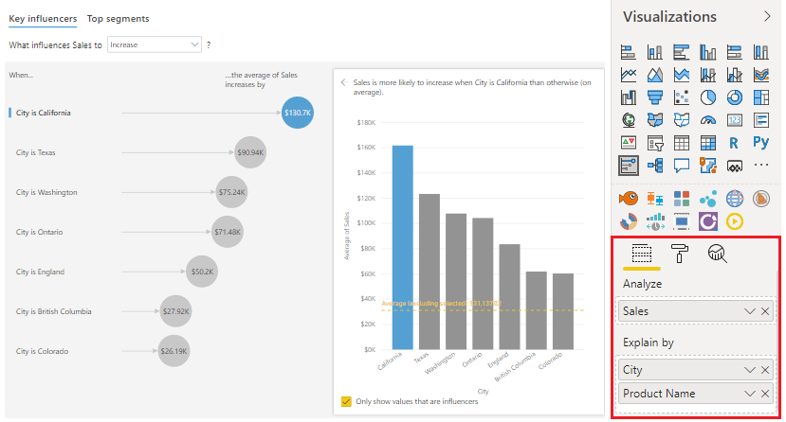
You can also use the What influences… drop-down list to see what caused the data to decrease or increase.

In the image above, the insight is that sales for California is likely to be 130,700.00 higher than sales in other cities

Use the Decomposition Tree Visual to Break Down a Measure
The decomposition tree visual will automatically aggregate your data and lets you drill down into your dimensions so that you can view your data across multiple dimensions

In order to describe the best way for using decomposition tree, it is better to describe a scenario
You have built visuals for the Supply Chain team, but the team wants to be able to analyse the percentage of products that the organization has on back order
in other words, the percentage of products that are out of stock

Hence, the decomposition tree does enable you to conduct root cause analysis in order to understand a measure better

Add the Decomposition tree visualization through the Visualization pane

Then in the Analyze field, also add the measure or aggregate that you want to analyse
In the Explain by field well, add the dimension(s) that you want to drill into. In this case,

The decomposition tree allows you to drill into your stated categories as seen by the list dropdown
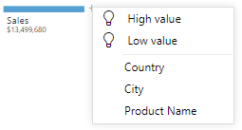

In this case, you want to analyse the Sales field by drilling down into a number of dimensions, such as Country, City, and Product

At the top of the list of dimensions, are two additional options marked as lightbulb icons.

These options are referred to as AI splits

They’ll automatically find high and low values in the data for you

AI Splits
This function works by considering all available fields and determining which one to drill into in order to get the highest / lowest value of the measure that is being analysed

The following image illustrates the results of selecting the High value AI split
